# **Experiment No.2**

# **Title: Laboratory on Statistics**

**Aim:** To find the probability for Binomial distribution and Normal distribution and verify the Normal approximation of Binomial distribution.

**Software used:** Programming language R.

x

**Code Statement:**

Wread.data <- read.csv("file1.csv")

1. Treating this value as ‘p’, calculate the following probabilities –
   1. What is the probability that in a randomly chosen sample of 10 persons, no one has travelled abroad?
   2. What is the probability that in a randomly chosen sample of 10 persons, exactly one has travelled abroad?
   3. What is the probability that in a randomly chosen sample of 10 persons, exactly two persons have travelled abroad?
   4. What is the probability that in a randomly chosen sample of 10 persons, exactly three persons have travelled abroad?
   5. What is the probability that in a randomly chosen sample of 10 persons, exactly four persons have travelled abroad?
   6. What is the probability that in a randomly chosen sample of 10 persons, exactly five persons have travelled abroad.
   7. What is the probability that in a randomly chosen sample of 10 persons, exactly six persons have travelled abroad?
   8. What is the probability that in a randomly chosen sample of 10 persons, exactly seven persons have travelled abroad?
   9. What is the probability that in a randomly chosen sample of 10 persons, exactly eight persons have travelled abroad?
   10. What is the probability that in a randomly chosen sample of 10 persons, exactly nine persons have travelled abroad?
   11. What is the probability that in a randomly chosen sample of 10 persons, all 10 persons have travelled abroad?
2. Plot the probability values as a Table / Bar graph/plot and interpret plot.
3. ?
4. What is the probability that in the randomly chosen sample of 100 persons at least 59 have travelled abroad?

Hint: Expected to perform Normal approximation for the binary distribution.

**Code:** *ds<-read.csv("C:\\Users\\agraw\\Desktop\\DS LAB\\Dataset(DSlab)\\Expt 2- Data set_Travelled abroad_csv.csv")*

*ds*

*p = sum(ds$Travelledabroad == 'Y')/nrow(ds)*

*print(p)*

*probv = dbinom(0:10,10,p)*

*print(probv)*

*data_frame1 <- data.frame(col1 = 0:10)*

*barplot(probv , names.arg = data_frame1$col1)*

*newprob = dbinom(0:100,100,p)*

*print(newprob)*

*barplot(newprob , names.arg = 0:100)*

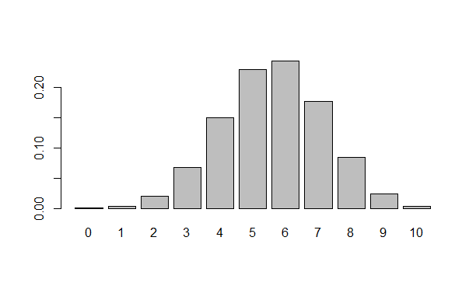

# **Results:** Display the output obtained on R console for all the cases. Also add the plots which you obtained. Give proper title to the plots as per the condition.

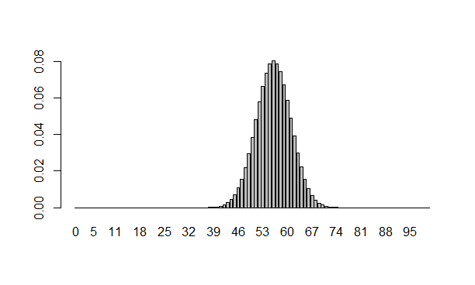

# **Conclusion: *(****Write the conclusion in your words)*